Josh Savage

Turn of week & month study

In 1988 a study was done by Joseph Lakonishock and Seymour Smidt to see if there existed abnormal returns in the stock market at the end of the month, end of week, mid-month December and holidays. The study found that in many cases there did exist abnormalities in the returns. My paper is looking to replicate there studies in the foreign exchange markets using the USDJPY, EURUSD and GBPJPY pairings for end of the month and end of the week effects. The tools I will be using to conduct this study are Bloomberg and sas.

The first step I took was to gather data. The data was easy to get access to, I collected daily spot prices from the Bloomberg terminal dating back to when these currencies openly traded on the market. The EURUSD opened on the market to trade in 1975 where as both the USDJPY and the GBPJPY opened in early 1971. The first thing I did was to eliminate blank data from the dataset then add weekday, day month and year variables to it. The next variable I added was a variable for the first day of the month then I used a lag in order to create variables for the last day of every month as well as one for the first three days. For these variables I made them all equal one if it was that certain day and a zero otherwise. By adding these together I was able to create a turn of the month variable. By finding the daily returns for each of the currencies and making adding a column for each I was then ready to run the a t test on it with the following results.

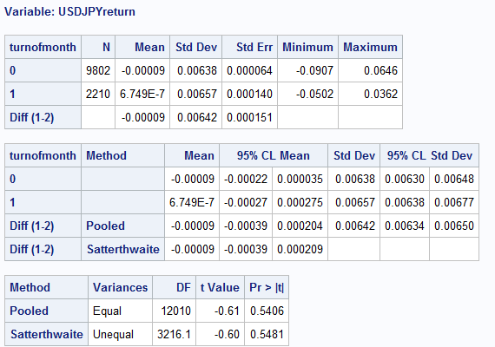

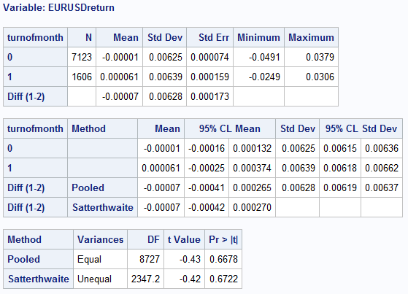

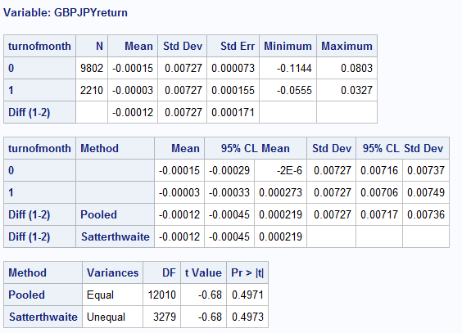

Of the three currency pairings none of the results were statistically significant. All the p values were rather high and the t values weren’t high enough. The closest was the GBPJPY which had a p value of .4971 and a t value of -.68. Reasons why the returns on turn of the month in the United States stock market and not in the different currency markets is unclear. My suspicion is that, while in the United States it is associated with payday for many being at the end of the month and therefore more spending at the end of the month, this doesn’t hold true internationally. This theory is but mere speculation though.

For the turn of the week I followed many of the same procedures as the turn of the month. I created the same weekday, day, month and year variables as before. I similarly created a variable for the last day of the week and the first day of the week and set it up so that if it was that day it showed a one and if not a zero. In the original study done by Lakonishock and Smidt they studied each Friday and Monday separately because they claimed that Friday generated abnormally high returns and Monday abnormally low returns. For this reason I also studied each differently. The following are the results for Friday.

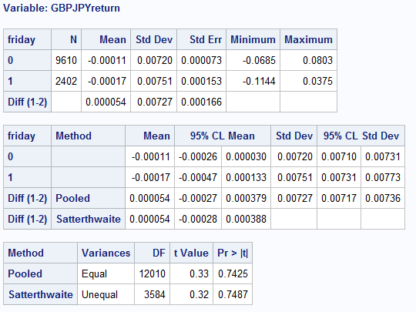

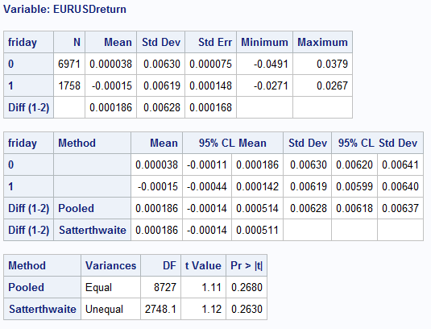

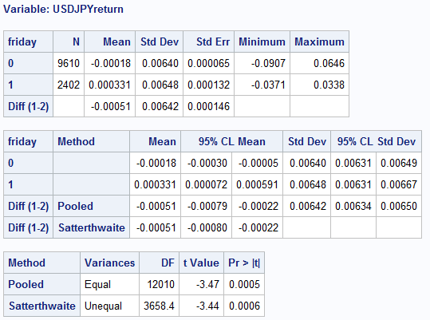

Here we can see that of the three the only one that is statistically significant is the USDJPY. Using the Pooled method we see the pvalue at .0005. With this I can say with confidence that it is significant. The returns for this currency on Fridays is at -.00051. This would result in a -2.65% return from market returns every year if traded upon every year. While this isn’t ground breaking returns it is significant and can lead to a slight edge. Now let’s see if Mondays look similar.

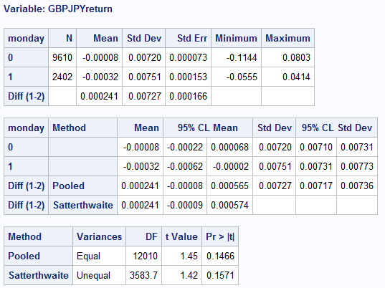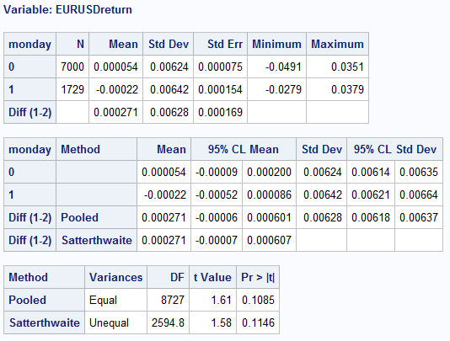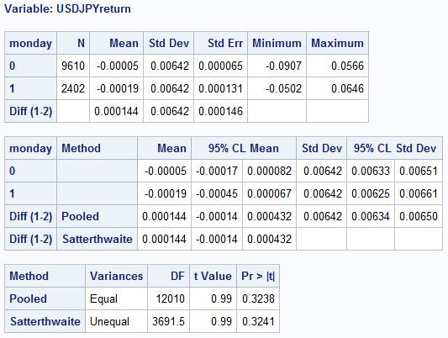

The Monday effect runs aground with nothing being statistically significant. The one notable case is the EURUSD, who’s p value is .1085 and is very close to being significant.

In conclusion, the tests done by Lakonishock and Smidt show that in the United States stock market abnormal returns can be achieved at the turn of the month and end of and beginning of the week but these patterns do not show up, for the most part, in the foreign exchange markets. The one exception is that of Friday returns for the USDJPY pairing.